NOVAC Technology Solutions



Software Requirement Specification

For

MARINE INSURANCE in Client Portal

Revision History

Version No. | Date | Reason For Changes | Author | Reviewer | Approver
Darft0.1 | 04-May-2023 | Draft | B.Emmanuel
1.0 | 22-May-2023 | Baseline version of draft | B.Emmanuel |  | Siddharth Pareek
Darft0.1.1 | 07-May-2023 | Draft | B.Emmanuel
Draft  1.2 | 08-May -2023 | Draft – Changes has been highlighted. | B.Emmanuel
Version  2.0 | 08-May -2023 | Baseline version | B.Emmanuel |  | Siddharth Pareek

Table of Contents
1. Introduction 4
1.1 Purpose 4
1.2 Project Scope 4
1.2.1 Features for Future Releases 4
1.3 References 4
1.4 System Description 5
1.5 Stakeholders 5
2. Functional Requirements 5
2.1 Login screen 6
2.2 Home screen 6
2.3 Dashboard screen for Marine Open Policy and Sales Turn over Policy 7
2.3.1 Declaration/ certificate generating screen 11
2.3.2 Bulk declaration upload screen 26
2.3.3 Claim Intimation screen. 27
2.3.4 Sum Insured Enhancement screen. 35
3. Interface Requirements 37
3.1 Internal Interfaces 37
3.1.1 Hardware Interface 37
3.1.2 Software Interface 38
3.1.3 Communication Interface 38
3.1.4 External Interfaces 38
3.1.4.1 Hardware Interface 38
3.1.4.2 Software Interface 38
3.1.4.3 Communication Interface 38
3.2 Operating Environment Requirement 38
3.2.1 Hardware Requirements 38
3.2.2 Software Requirements 38
3.2.3 Network Requirements 38
3.2.4 Operational scenarios: 38
3.3 Non Functional Requirements (NFR) 39
3.3.1 Reliability 39
3.3.2 Performance 39
3.3.3 Security 39
3.3.4 Usability 39
3.3.5 Other Requirements 39
3.4 Open Issues 39
3.5 Acceptance Criteria 39
4. Appendix A 39

Introduction

Purpose
The document is prepared to understand the issuance of Marine Policy Declaration (Single & Bulk)/ Certificate through Web portal. This portal access will have to be given to the client who has opted “Marine Open” or “Sales Turn Over Policy”. This document is being prepared in reference to:
  - The Indian Insurance act.
  - Guidelines, circulars, instructions and directions released from time to time by Insurance Regulatory and Development Authority of India (IRDA).
  - Other online public library documents.

Project Scope
The scope of the application is to perform the following.
1. Collection and recording of insured details.
2. Collection and recording of the subject matter of insurance i.e. Commodities to be shipped
3. Assessing and accepting the sum insured amount for the required coverage.
4. To calculate and display the premium against the sum insured.
5. Declaration/ Certificate generation based on the inputted data.
6. To accept and account the Sum Insured and generate declaration/certificate.

Features for Future Releases
Not Applicable. All the relevant necessary futures are included.

References

System Description
- The Scope of Marine Insurance Client Module in Web portal is restricted to Marine Open Policy and Sales Turn over Policy.
- The client can issue certificates and declare their regular shipment details in this portal.
- The scope of this module in Web Portal is currently restricted to Clients and only view rights will be given to the Branch user and View/ Edit rights for HO User in core application.
- Declaration/ certificate issuance will be done only in client portal, not in core application - As confirmed in the meeting

Flow of the System:

1. Client will log in with the user credentials.
2. Post log in, User will be redirected to Home page to select type of policy which is Marine open policy and Sales turn over Policy.
3. Then User will be directed to the Declaration screen, where user will
input Basic details of Insured, details of Subject Matter Insured and Shipment details.
4. Post entering the basic details, user will be able to validate the inputs and save as draft.
5. Then post successful validation, the User will be able to do declaration and generate certificate.

Stakeholders

Stakeholder(s) | Relationship  (Client/Internal) | Roles and Responsibilities
Siddharth Pareek | Client | Client Representative
D Dinesh | Internal | Vice President & Chief Software Officer
Vijay N Menon | Internal | Associate Vice President
Lavanya | Internal | Development coordinator
B.Emmanuel | Internal | Business Analyst
Saravana Muthu | Internal | Testing coordinator

Functional Requirements
Marine Policy Declaration/ Certificate generation through Web portal for client.

Login screen
- Post Policy issuance, the client should be given client portal to issue certificate/ declaration (Single & Bulk).
- The functionality will be same as per the existing wed portal.
- Mail ID and auto generated one-time password should be sent to the client. Mail ID will be default login credential and thereby provision for client to change the password should be provided.

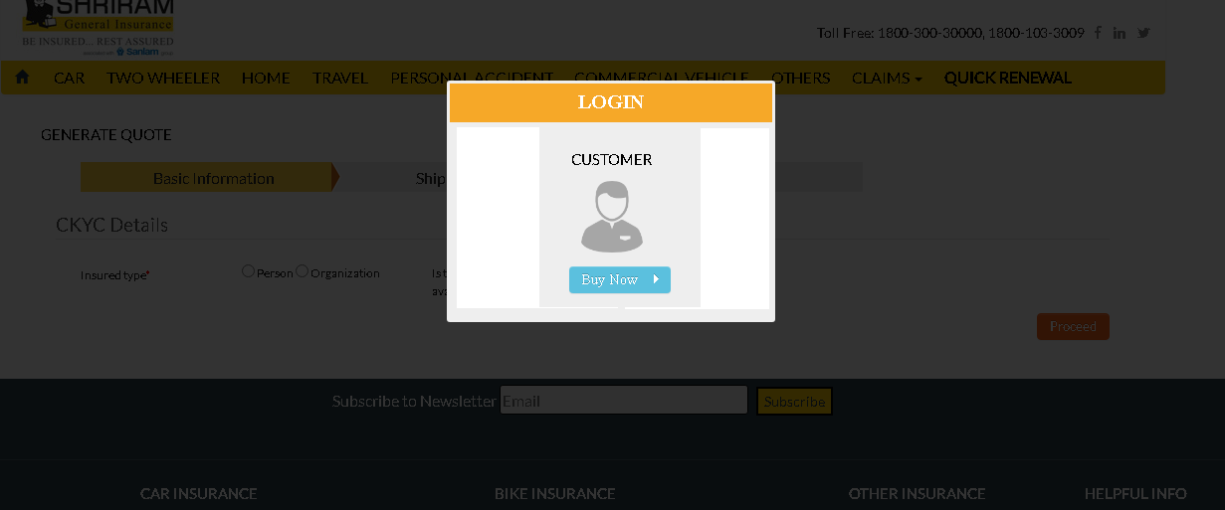

Home screen
- The screen should display two separate icons by default but client should be allowed to select as per the policies taken by the client(User), either it should be “Marine open policy” or Sales Turn over Policy”.
- Once the user selects the any of the options for which the user has not taken the policy, then there should be Pop up message as “No record found”.
- Once the user clicks any of the icon below, dashboard screen should be displayed.
- Icon One: “Marine Open Policy”
- Icon One: “Sales Turn over Policy”
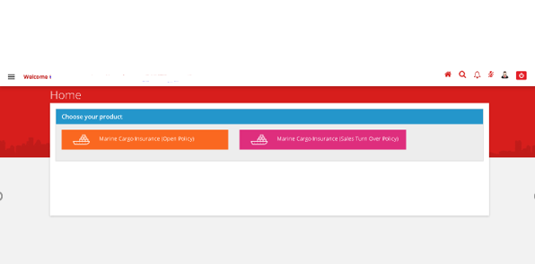
- Claim Intimation functionality and validation will be given only after finalized claims SRS.
- Reminder mail/message format for non-submission/updating declaration/certificate in portal--> If insured is not updating the declaration within 30 days then reminders is to be given to insured’s mail ID and SMS (message on what’s up number – to be checked) …after which we need to give regular reminders in every 7 days till the insured update the same in the portal. Format attached in reference 1.3.

Dashboard screen for Marine Open Policy and Sales Turn over Policy

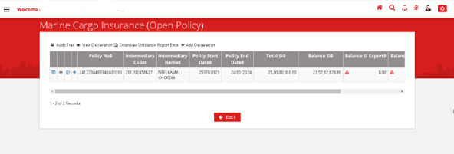
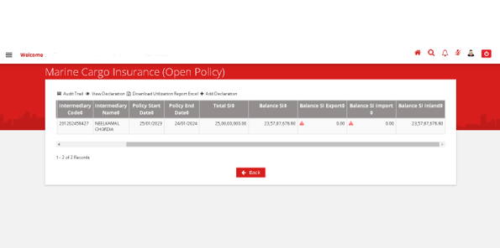

Below mentioned buttons should be given in the dashboard screen.
View Declaration button - > “view icon” - > User should be allowed to view the draft Certificate/declaration
Add Declaration button- > + - > User should be redirected to declaration/certificate generating screen.

Sl. No. | FIELD NAME | FIELD TYPE | INPUTS | VALIDATION
1 | Policy Number | Auto Populate and read only |  | This field should be auto fetched from Nova Core Application. (policy details)
2 | Intermediary code | Auto Populate and read only |  | This field should be auto fetched from Nova Core Application. (policy details)
3 | Intermediary Name | Auto Populate and read only |  | This field should be auto fetched from Nova Core Application. (policy details)
4 | Policy start Date | Auto Populate and read only |  | This field should be auto fetched from Nova Core Application. (policy details)
5 | Policy End Date | Auto Populate and read only |  | This field should be auto fetched from Nova Core Application. (policy details)
6 | Total Sum Insured | Auto Populate and read only |  | 1.This field should be auto fetched from Nova Core Application. (policy details)  2. This field should display and sum up all the sum Insured which the client has opted for during policy issuance. I;e The client can opt for any one or all the three-> Export SI, Import SI and Inland SI in “Voyage” field of Proposal screen
7 | Balance Sum Insured | Auto Populate and read only |  | 1. This field should be auto populated after the declaration/ certificate generation is finalized  2. This field should display and sum up all the balance sum Insured fetched from S.No 46.1 to 46.3.  I;e The client can opt for any one or all the three-> Export SI, Import SI and Inland SI in “Voyage” field of Proposal screen, so the balance sum insured after finalization of certificate/ declaration adding all three should be displayed. (46.1+46.2+46.3)
8 | Balance Sum Insured Export | Auto Populate and read only |  | 1.This field should be auto populated after the declaration/ certificate generation is finalized  2. This field should display the sum insured displayed in s.no 46.1 after finalization of certificate/ declaration by the user.  3. The above validation will be applicable only If the user has opted for export Sum insured during the policy generation, if not the filed should be display ‘0’.
9 | Balance Sum Insured Import | Auto Populate and read only |  | 1.This field should be auto populated after the declaration/ certificate generation is finalized  2. This field should display the sum insured displayed in s.no 46.2 after finalization of certificate/ declaration by the user.  3. The above validation will be applicable only If the user has opted for Import Sum insured during the policy generation, if not the filed should be display ‘0’.
10 | Balance Sum Insured Inland | Auto Populate and read only |  | 1.This field should be auto populated after the declaration/ certificate generation is finalized  2. This field should display the sum insured displayed in s.no 46.3 after finalization of certificate/ declaration by the user.  3. The above validation will be applicable only If the user has opted for Import Sum insured during the policy generation, if not the filed should be display ‘0’.

Declaration/ certificate generating screen
Below mentioned some fields will be applicable for both MOP and STOP policy.
Bulk Declaration – Applicable for MOP and STOP Policy.
Validations are mentioned against each field.
*MOP – Marine open policy and STOP – Sales turn over policy.
*SD – Single declaration, SC – single certificate and BD – Bulk declaration.

Policy/Shipment Details/Declaration
(Main Heading)
Policy Info
1 | Policy Number | Auto Populate and read only |  | This field should be auto fetched from Nova Core Application. (policy details)  Applicable for both MOP and STOP
2 | Policy Start date | Auto Populate and read only |  | This field should be auto fetched from Nova Core Application. (policy details)  Applicable for both MOP and STOP
3 | Policy End Date | Auto Populate and read only |  | This field should be auto fetched from Nova Core Application. (policy details)  Applicable for both MOP and STOP
4 | Certificate / Declaration type | Check Box | 1. Single Declaration  2. Single certificate  3. Bulk Declaration- Monthly/ Quarterly/ Annual. | 1. This field is mandate and the user will be allowed to tick any one of the check box only.  2. If the user does not click either of the check box, then there should be a pop message. “Please select either Single Certificate or Single Declaration or Bulk Declaration - Monthly / Quarterly / Annual.”  3. There should be a general Message displayed as below.  “Please exclude declaration for which you have already generated certificates”  4. If user selects “. Bulk Declaration- Monthly/ Quarterly/ Annual”, then the “Bulk declaration upload screen” should be enabled along with certain fields.  5. If user selects “Single Declaration” in the drop down single declaration format will be applicable as attached in reference 1.3  And if user selects “single certificate” single certificate format will be applicable as attached in reference 1.3  And if user selects “Bulk Declaration” Bulk Declaration format will be applicable as attached in reference 1.3
Declaration/ Certificate
5 | Declaration Type | Auto populate and read only | Voyage wise – certificate and declaration | Auto populate and read only when if user selects “Single Declaration & Single certificate”
6 | Declaration/certificate date | Date picker |  | - This field should by default display the current date.  - This field is mandate and the user should not be allowed to select past date.  - Applicable only for “Single Declaration & Single certificate”
7 | Declaration/certificate Time | Time picker |  | - This field should by default display the current time and this field is mandate  Example: 13:23 Hr:Mins  - Applicable only for “Single Declaration & Single certificate”
8 | Certificate Holder Address | Auto Populate and read only |  | This field should be auto fetched from Nova Core Application. (policy details - Insured Address)  Applicable for both MOP and STOP.
9 | Certificate Holder Name | Auto Populate and read only |  | This field should be auto fetched from Nova Core Application. (policy details - Insured name)  Applicable for both MOP and STOP
Voyage
10 | Voyage Type | Drop Down | - Inland  - Export  - Import  - FOB | - User selection and Mandate.  - If the user selects “Single Declaration “in S.no 4 only “Inland” will be enabled.  - If the user selects “Single certificate” in S.no 4 only “Export and Import” will be enabled.  - And applicable for STOP and MOP – for type of declaration (SC, SD)
11 | Voyage From Country | Text Field |  | 1.User Selection from the list of the countries available.  2.This field should be mandatory.  3. If shipment is “From” below mentioned countries, then the system should popup an error message stating that, “transit between these countries are not allowed”  - Afghanistan  - Cuba  - Iraq  - Somalia  - Syria  - Iran  - Sudan  - Myanmar  - Yemen  - Libya  - North Korea  - And applicable for STOP and MOP – for type of declaration (SC, SD)
12 | Voyage To Country | Text Field |  | 1.User Selection from the list of the countries available.  2. This field should be mandatory.  3. If shipment is “To” below mentioned countries, then the system should popup an error message stating that, “transit between these countries are not allowed”  - Afghanistan  - Cuba  - Iraq  - Somalia  - Syria  - Iran  - Sudan  - Myanmar  - Yemen  - Libya  - North Korea  - And applicable for STOP and MOP – for type of declaration (SC, SD)
13.1 | Voyage From | Text field |  | 1.User Selection  2. This field should be mandatory only if user selects inland. And applicable for STOP and MOP – for type of declaration ( SD)
13.2 | Voyage To | Text field |  | 1.User Selection  2. This field should be mandatory only if user selects inland. And applicable for STOP and MOP – for type of declaration ( SD)
14 | Survey Destination | Text Field |  | 1.User selection and non- Mandate.  2.Attached list in reference 1.3  - This field will be not applicable for STOP  - And applicable for Both MOP and STOP– for all type of declaration (SC, SD and BD)
Shipment details
15 | Invoice No | Text field |  | - User Enterable and Mandate.  - Applicable for  MOP –only for declaration type SC and SD.  - This field will be not applicable for BD.
16 | Invoice Date | Date picker |  | - User selection and Mandate.  - Applicable for  MOP –only for declaration type SC and SD.  - This field will be not applicable for BD.
17 | LR/RR/AWB/RPP/ and B/L No | Free Text field |  | - User Enterable and Mandate.  - Applicable for  MOP –only for declaration type SC and SD.  - This field will be not applicable for BD.
18 | LR/RR/AWB/RPP/ and B/L Date | Date picker |  | - User selection and Mandate.  - In Bulk upload format, this field will be captured as “DATE OF DISPATCH OF MATERIAL”  - Applicable for  MOP –only for declaration type SC and SD.  - This field will be not applicable for BD.
19 | Mode of Transit | Drop Down Field | - ROAD  - RAIL  - AIR  - REGISTERED POST PARCEL  - COASTA  - INLAND WATER WAYS  - COURIER  - SEA  - ROAD/RAIL  - ROAD/RAIL/AIR  - ROAD/RAIL/AIR/RPP  - ROAD/RAIL/AIR/RPP/COURIER/SEA  - ROAD/RAIL/AIR/RPP/COURIER/IWW  - SEA/AIR  - SEA/AIR/RPP  - SEA/ RAIL/ ROAD/ AIR  - SEA/ RAIL/ ROAD/ AIR/COURIER  - RAIL/ ROAD/ AIR/COURIER  - RAIL/ ROAD/ MULTI MODEL  - AIR/ROAD | 1.User Selection.  2.This field will be mandatory.  3. Applicable for MOP –only for declaration type SC and SD.  4.This field will be not applicable for BD.
20 | Limit per sending/bottom | Auto populated and Read only |  | - It should be auto populated from the policy if applicable.  And the user should not be allowed to issue the certificate/declaration if the limit exceeds as per the limit mentioned in the policy for a single certificate/declaration i:e per shipment/ consignment while clicking “Calculate Premium” button.  - And applicable for Both MOP and STOP– for all type of declaration (SC, SD and BD)
20.1 | Limit per Location | Auto populated and Read only |  | - It should be auto populated from the policy if applicable.  And the user should not be allowed to issue the certificate/declaration if the limit exceeds as per the limit mentioned in the policy for a single certificate/declaration i:e per shipment/ consignment with respect to the location. (Destination location) while clicking “Calculate Premium” button.  - And applicable for Both MOP and STOP– for all type of declaration (SC, SD and BD)
S.No 21 – 31 will be Non- Mandatory and applicable for MOP and STOP - for all type of declaration (SC, SD and BD)
21 | Estimated Date Of Shipment | Date picker |  | User Enterable and non- Mandate.
22 | Vessel/Airline Name | Free Text field |  | User Enterable and non- Mandate.
23 | Port Of Loading | Free Text field |  | User Enterable and non- Mandate.
24 | Port Of Discharge | Free Text field |  | User Enterable and non- Mandate.
25 | Consignee Name | Text field |  | User Enterable and non- Mandate.
26 | Consignee Address | Free Text field |  | User Enterable and non- Mandate.
27 | L/C Number | Free Text field |  | User Enterable and non- Mandate.
28 | LC Conditions | Free Text field |  | User Enterable and non- Mandate.
29 | Additional Insured / Financial Interest | Text field |  | User Enterable and non- Mandate.
30 | Marks & nos./ Packing/ Container nos | Free Text field |  | User Enterable and non- Mandate.
Other details
31 | LC Code | Free Text field |  | User Enterable and non- Mandate.
Sum Insured details
S.No 32 – 35 will be Mandatory Applicable for STOP & MOP –only for declaration type SC and SD.
32 | Currency code (as per invoice) | Text field |  | - User should be allowed to search the currency code same functionality as proposal module and mandate  - Currency code list attached in Reference 1.3
33 | Exchange Rate | Text field |  | - User enterable and mandatory  - The user should be allowed to enter Numeric along with the decimal value.
34 | Invoice Amount ( FC ) | Numeric |  | - User enterable and mandatory  (FC – Foreign currency)  - The user should be allowed to enter Numeric along with the decimal value.
35 | Invoice Amount ( INR ) | Auto Populate and read only |  | - This field should auto populate multiplying the value mentioned in S.no 33 and S.no 34.  - For example,  - Invoice currency is USD  - Rate of Exchange is 80 - S.no 33  - Invoice amount(FC) is 10000 - S.no 34  Then the Invoice amount(Rs) will be 800000.
36 | Terms Of SALE/INCO Terms | Drop Down | 1.Cost Insurance and Freight (CIF)  2.Cost and Insurance (C&I)  3.Cost and Freight (C&F)  4.Free on Board (FOB)  5.Prime Cost plus expenses of and incidental to transit and charges of Insurance  6.CIF+Duty  7.CIF+Duty+Increased value  8.Duty  9.Duty+Increased value  10.Increased value  11.CIF + FOB  12.CI + FOB  13.CF + FOB  14.Prime Cost only  15.Cost of Goods  16.Ex-works  17.Carriage Insurance Paid To (CIP)  18.FCA-Free Carrier  19.CPT  20.DDP  21.DDU  22.Delivery at Terminal (DAT)  23.Invoice  24.Delivered at Place(DAP) | 1. User Selection and mandatory and applicable for MOP and STOP - for all type of declaration (SC, SD and BD)
37 | Percentage of Valuation | Numeric |  | 1.User Enterable.  2.This field will be non-mandatory.  3. This field will be applicable for all MOP and STOP policy  4. For “Marine Open policy and Sales turn over policy” --For example,  - Invoice currency is USD  - Rate of Exchange is 80  - Invoice amount(FC) is 10000 - S.no 12.3  - Percentage of valuation is 10%, - S.No 7.1 i:e Invoice value+10%  Then the “Sum Insured” will be 11000. (10% added)
38 | Duty SI (INR ) | Numeric |  | - User enterable and non-mandatory  - The user should be allowed to enter Numeric along with the decimal value.  - This particular field will be applicable for MOP and STOP - only for declaration type SC and SD.
39 | Subject Matter Insured (Commodity description) | Text field |  | - User enterable and mandatory  - This particular field will be applicable for MOP and STOP - only for declaration type SC and SD.

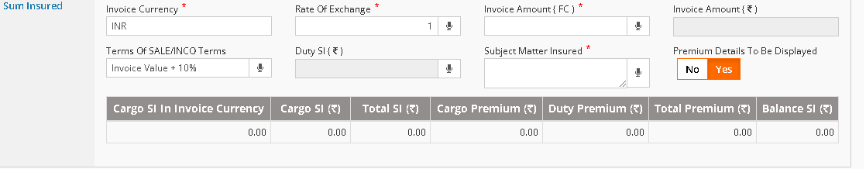

Sum Insured Grid – Below mentioned field should be enabled after user clicks “Validation” button. And this Grid will be Applicable for MOP only for declaration type SC and SD.
40 | Cargo SI In Invoice Currency | Auto Populate and read only |  | - This field should auto populate considering the value mentioned in S.no 34 and S.no 36.  - For example,  - Invoice currency is USD  - Rate of Exchange is 80  - Invoice amount(FC) is 10000 - S.no 34  - Terms Of SALE/INCO Terms – can be CIF+10%, Invoice value+10%  Then the “Cargo SI In Invoice Currency” will be 11000.(10% added)
41 | Cargo SI (INR) | Auto Populate and read only |  | - This field should auto populate considering the value mentioned in S.no 35 and S.no 36.  - For example,  - Invoice currency is USD  - Rate of Exchange is 80  - Invoice amount(FC) is 10000 - S.no 34  - Invoice amount(Rs) is 800000 - S.no35  - Terms of SALE/INCO Terms –> can be CIF+10%, Invoice value+10%  Then the “Cargo SI (Rs)”will be Rs900000.(10% added).
42 | Total SI (INR) | Auto Populate and read only |  | This field functionality and validation will be same as above field “Cargo SI (Rs)”s.no 41
43 | Cargo Premium (INR) | Auto Populate and read only |  | - This field should take the functionality and validation mentioned for “Premium calculation logic” in the Nova Core Application. (policy details)  - With respect to the s.no 42 mentioned above, the calculation has to be triggered.  - Same rate will be applicable for calculating the premium which was used for Policy issuance.
44 | Duty Premium (INR) | Auto Populate and read only |  | - This field should take the functionality and validation mentioned for “Premium calculation logic” in the Nova Core Application. (policy details)  - With respect to the s.no 38 mentioned above, the calculation has to be triggered.  - Same rate will be applicable for calculating the premium which was used for Policy issuance.
45 | Total Premium (INR) | Auto Populate and read only |  | - This field should auto populate summing up the value mentioned in S.no 43 and S.no 44.  - For example,  - Cargo Premium (Rs) - 10  - Duty Premium (Rs)- 2  Then the “Total Premium (Rs)” will be Rs12.
46 | Balance SI (INR) | Auto Populate and read only |  | This field should Auto Populate the sum insured subtracting the “Total SI (Rs)” s.no 42
46.1 | Balance Sum Insured Export | Auto Populate and read only |  | - This field should Auto Populate the sum insured subtracting the “Total SI (Rs)” s.no 42  - This field should be enabled only if the user has selected “Export” in Voyage Type(S.No 10) else it should display ‘0’
46.2 | Balance Sum Insured Import | Auto Populate and read only |  | - This field should Auto Populate the sum insured subtracting the “Total SI (Rs)” s.no 42  - This field should be enabled only if the user has selected “Import” in Voyage Type(S.No 10) else it should display ‘0’
46.3 | Balance Sum Insured Inland | Auto Populate and read only |  | - This field should Auto Populate the sum insured subtracting the “Total SI (Rs)” s.no 42.  - This field should be enabled only if the user has selected “Import” in Voyage Type(S.No 10) else it should display ‘0’

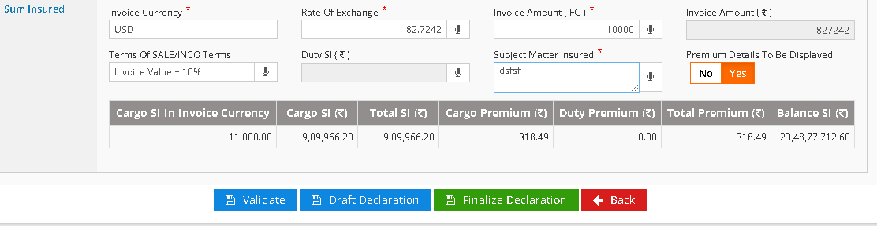

47 | Calculate Premium | Button |  | - The fields mentioned in “Sum Insured Grid” will be displayed as per the functionality and validations mentioned above if the user clicks this button.  - Limit per sending/bottom and Limit per Location validation mentioned below in s.no 10 & 11 will be applicable here when the user clicks this button. And there should be a pop error Message stating “Limit per sending value is exceeded the limit as per policy terms, please contact branch to increase the limit”  - If the Sum Insured for which the certificate/declaration is being generated is more than the amount mentioned in the S.No 46, then the user should not be allowed to generate certificate/declaration and Error message should be pop up stating “ The balance sum insured is inadequate to generate the certificate/declaration, please enter Invoice value less than the balance sum insured to proceed. (or) Intimate the branch through “Sum insured enhancement” facility to increase the existing sum insured”
48 | Draft Declaration | Button |  | - The Record will be saved and the draft version of the Declaration/ certificate will be generated if the user clicks this button.  - And the user can view the draft version of the Declaration/ certificate in PDF format and also in the “View Declaration” button in dashboard.
49 | Finalized Declaration | Button |  | If the user clicks this button. The draft version of the Declaration/ certificate generated will be finalized and the user can view the final certificate
50 | Download certificate/ declaration | Button |  | The user should be allowed to download the certificate/ declaration if the user clicks this button.  Note: If user selects “Single Declaration” in the drop down in S.No 4, single declaration format will be applicable as attached in reference 1.3  And if user selects “single certificate” single certificate format will be applicable as attached in reference 1.3
50 | Back | Button |  | The screen will Again be redirected to the dashboard screen

Bulk declaration upload screen
Along with the above mentioned few fields for BD, below mentioned fields will be enabled for MOP and STOP for BD only.
By default, we will consider “Inland sum Insured” for bulk declaration to display the balance sum insured.
This below fields should be enabled only if the user selects “Bulk Declaration” in Type of declaration field.
1 | Declaration date | Date picker |  | 1. This field should by default display the current date.  2. This field is mandate and the user should not be allowed to select past date.
2 | Declaration Period From | Date picker and Dropdown(Month) | Months should be displayed in the LOVs. (Jan – Dec) | - User selection and mandate
3 | Declaration period to. | Date picker and Dropdown(Month) | Months should be displayed in the LOVs. (Jan – Dec) | - User selection and mandate  - User should not be allowed to select the date and month prior to the “Declaration period from” date and month.
4 | File Upload - Browse | Button | No Input | 1. On Clicking the button, User can search the file for uploading.  2. The Selected File should be in “excel” format as attached in the reference 1.3.  3. If any other format is selected, there should be an error message popping to upload the correct format.
5 | Upload | Button | No input | 1) On Clicking the Upload button, the file has to be uploaded successfully.  2) System should generate the Declaration Number on Successful Uploading.
6 | Upload Error log | Button | No input | 1.If the upload file is not successful.  2.If the user uploads the data which is irrelevant to the fields and its validations, then those fields alone should be logged in this field for user reference to change those fields and upload again.  - Date format – 02-May – 2023  - And the date in “DATE OF DISPATCH OF MATERIAL” in column “F” should fall in between the Declaration from and to period only.
7 | Download declaration | Button |  | The user should be allowed to download the declaration if the user clicks this button.  Format as attached in Reference 1.3
8 | Close | Button | No Input | On Clicking “Close” button, System should close the Screen.

Limit per sending/bottom and Limit per Location validation will be applicable in bulk declaration too when the user clicks validation button. And there should be a pop up error Message stating “Limit per sending value is exceeded the limit as per policy terms, please contact branch to increase the limit or remove the particular entry to proceed with declaration” and this above conditions will validate each entry with respect to the “Total Amount” in the upload format which is in column “I”

If the Total Sum Insured (The “Total Amount” in the upload format which is in column “I”) for which the declaration is being generated as bulk is more than the amount mentioned in the S.No 46, then the user should not be allowed to generate certificate/declaration and Error message should be pop up stating “ The balance sum insured is inadequate to generate the certificate/declaration, please enter Invoice value less than the balance sum insured to proceed (or) remove the particular entry to proceed with declaration (or) Intimate the branch through “Sum insured enhancement” facility to increase the existing sum insured”

Claim Intimation screen.
Sl. No. | FIELD NAME |  | FIELD TYPE |  | INPUTS | VALIDATION
Policy Information
Basic Information
1 | Policy Number |  | Auto populated and read only |  |  | This field will be auto populated from the Policy master
2 | Proposal Number |  | Auto populated and read only |  |  | This field will be auto populated from the Policy master
3 | Policy Start Date & Time |  | Auto populated and read only |  |  | This field will be auto populated from the Policy master
4 | Policy End Date & Time |  | Auto populated and read only |  |  | This field will be auto populated from the Policy master
5 | Sum Insured |  | Auto populated and read only |  |  | This field will be auto populated from the Policy master
6 | Net Premium Amount |  | Auto populated and read only |  |  | This field will be auto populated from the Policy master
7 | Calculation Type |  | Auto populated and read only |  |  | This field will be auto populated from the Policy master
8 | Policy Status |  | Auto populated and read only |  |  | This field will be auto populated from the Policy master
9 | Product Type |  | Auto populated and read only |  |  | This field will be auto populated from the Policy master
10 | Division Code |  | Auto populated and read only |  |  | This field will be auto populated from the Policy master
10 | Agent code and name |  | Auto populated and read only |  |  | This field will be auto populated from the Policy master
Claim Details
Intimation Details
1 | Policy Number | Auto populated and read only |  |  |  |  | This field will be auto populated and read only from the Policy master
2 | Intimated By | Drop down field |  | 1.Insured  2.Representatives  3.Others |  |  | 1.User selection
3 | Intimator name* | Auto populated and editable |  |  |  |  | 1.If Type of Intimator field is selected as Insured then the Insured name will be displayed from the policy master and the user will be able to edit the same  2.If the user selects the Type of Intimator field as other than Insured then this will be a free text field.
4 | Intimator Contact number* | Auto populated and editable |  |  |  |  | 1.If Type of Intimator field is selected as Insured then the Insured contact number will be displayed from the policy master and the user will be able to edit the same  2.If the user selects the Type of Intimator field as other than Insured then this will be a numeric field with Mobile number validations applicable.
5 | Intimation Date and Time* | Auto populated and read only |  |  |  |  | This field will be auto populated as Current date and time
6 | Alternate Mobile Number | Numeric field |  |  |  |  | 1.User input field with mobile number validations applicable
7 | Language* | Drop down field |  | 1.Tamil  2.English  3.Hindi  4.Malayalam  5.Telugu  6.Kannada  7.Others |  |  | 1.User selection
8 | Loss Date and Time* | Date and Time picker field |  |  |  |  | 1.Selected date and time should be within the policy period  2.Selected date and time should not be greater than the Intimation date and time
9 | Loss Description* | Free Text field |  |  |  |  | 1.User input
10 | Claim Type* | Auto populated and Read only |  |  |  |  | This field will be auto populated and read only from the Claim Registration module
11 | Cause of Loss* | Search |  |  |  |  | 1.User can search and select the applicable cause of loss  2.This should be a mandatory field.  3. The cause of loss LOVs are updated in the Excel sheet attached in the reference section.
12 | Others Description | Free text field |  |  |  |  | 1.This field will be mandatory only if the cause of loss field is selected as Others else this field will not be displayed.
13 | Nature of Loss* | Drop down field |  | 1. Barratry  2. G.A.(General Average)  3. Collision damage  4. Contamination  5. Damage by extraneous substances  6. Explosion  7. Frustration of voyage  8. General average sacrifice  9. Improper stowage  10. Infestation  11. Sinking  12. Non delivery  13. Stranding  14. Others  15. partial Delivery  16. Actual Total loss  17. Constructive Total loss  18. Liability  19. Particular Average  20. Salvage  21. Loss with sue and labour  22. Sue and labour alone  23. Insolvency |  |  | 1.User selection  2.User should have an option of selecting multiple options  3.This should be a mandatory field.
14 | Provision Amount* | Numeric input |  |  |  |  | 1.Even if the user selects multiple Nature of loss, the user will be allowed to input only one provision amount i.e., there will be no separate provision to capture for each nature of loss.  2. If the insured has utilized 100% of SI through Claim then no further Claim should be accepted on the Policy
15 | Reason for Delay | Free Text field |  |  |  |  | This field will be mandatory only if the difference between the loss date and the Intimation date is more than 14 days i.e., on the 15th day this field should be made mandatory
16 | Next | Button |  |  |  |  | Selecting this button, the user will be directed to the Intimation screen by validating the mandatory fields captured from the above fields
17 | Close | Button |  |  |  |  | Selecting this button, the user will be directed to the NOVA Home screen
Shipment Details
1 | Voyage from Country | Drop Down Field |  |  |  |  | 1.User Selection from the list of the countries available.  2.This field should be mandatory.
2 | Voyage to Country | Drop Down Field |  |  |  |  | 1.User Selection from the list of the countries available.  2.This field should be mandatory.
3 | Voyage From | Text Field |  |  |  |  | 1.User Enterable.  2.This field should be mandatory.
4 | Voyage To | Text Field |  |  |  |  | 1.User Enterable.  2.This field should be mandatory.
5 | Voyage | Drop Down |  | - Inland  - Export  - Import  - FOB |  |  | 1.User Selection.  2.This field will be mandatory.  3. User can select Multiple LOVs for “Marine Open Policy” and “Sales Turnover policy”
6 | Mode of Transit | Dropdown |  | - ROAD  - RAIL  - AIR  - REGISTERED POST PARCEL  - COASTA  - INLAND WATER WAYS  - COURIER  - SEA  - ROAD/RAIL  - ROAD/RAIL/AIR  - ROAD/RAIL/AIR/RPP  - ROAD/RAIL/AIR/RPP/COURIER/SEA  - ROAD/RAIL/AIR/RPP/COURIER/IWW  - SEA/AIR  - SEA/AIR/RPP  - SEA/ RAIL/ ROAD/ AIR  - SEA/ RAIL/ ROAD/ AIR/COURIER  - RAIL/ ROAD/ AIR/COURIER  - RAIL/ ROAD/ MULTI MODEL AIR/ROAD |  |  | 1.user selection and mandatory
7 | Basis of Valuation | Auto populated and Read only |  |  |  |  | It should be auto populated from the policy if applicable
8 | Percentage of Valuation | Auto populated and Read only |  |  |  |  | It should be auto populated from the policy if applicable
9 | Terms of sale | Drop Down |  | 1.Cost Insurance and Freight (CIF)  2.Cost and Insurance (C&I)  3.Cost and Freight (C&F)  4.Free on Board (FOB)  5.Prime Cost plus expenses of and incidental to transit and charges of Insurance  6.CIF+Duty  7.CIF+Duty+Increased value  8.Duty  9.Duty+Increased value  10.Increased value  11.CIF + FOB  12.CI + FOB  13.CF + FOB  14.Prime Cost only  15.Cost of Goods  16.Ex-works  17.Carriage Insurance Paid To (CIP)  18.FCA-Free Carrier  19.CPT  20.DDP  21.DDU  22.Delivery at Terminal (DAT)  23.Invoice  24.Delivered at Place(DAP) |  |  | 1.User Selection.  2.This field will be mandatory.
10 | Limit per sending/bottom | Auto populated and Read only |  |  |  |  | It should be auto populated from the policy if applicable.  And the user should not be allowed to issue the certificate/declaration if the limit exceeds as per the limit mentioned in the policy for a single certificate/declaration i:e per shipment/ consignment while clicking “Calculate Premium” button.
11 | Limit per Location | Auto populated and Read only |  |  |  |  | It should be auto populated from the policy if applicable.  And the user should not be allowed to issue the certificate/declaration if the limit exceeds as per the limit mentioned in the policy for a single certificate/declaration i:e per shipment/ consignment with respect to the location. (Destination location) while clicking “Calculate Premium” button.
12 | LR/RR/AWB/RPP No | Free Text |  |  |  |  | 1.User Enterable.  2.This field should not be mandatory.  3. This field should be enabled only if the “Claim Type” is “Marine Specific Voyage”
13 | LR/RR/AWB/RPP Date | Date Picker |  |  |  |  | 1.User Enterable.  2.This field should not be mandatory.  3. This field should be enabled only if the “Claim Type” is “Marine Specific Voyage”
14 | Bill of Lading | Free text field |  |  |  |  | 1.User Enterable.  2.This field should not be mandatory.  3. This field should be enabled only if the “Claim Type” is “Marine Specific Voyage”
15 | Sum Insured | Auto populated and Read only |  |  |  |  | It should be auto populated from the policy.
The below fields will be enabled, only if the user selects either any one of the voyage type -> Export, Import in Shipment Details.
16 | Invoice Currency | Auto populated and Read only |  |  |  |  | It should be auto populated from the policy
17 | Rate Of Exchange | Auto populated and Read only |  |  |  |  | It should be auto populated from the policy
18 | Invoice Amount ( FC ) | Auto populated and Read only |  |  |  |  | It should be auto populated from the policy
19 | Invoice Amount ( Rs) | Auto populated and Read only |  |  |  |  | It should be auto populated from the policy
20 | Register claim | Button |  |  |  |  | If User selects this field, then same will record will be reflected in the Claim screen in NOVA.

Sum Insured Enhancement screen.
The user can send Endorsement request to the Branch user for Sum Insured enhancement after which the branch user will process the same and send request to HO UW team for approval.
By default, the endorsement request will trigger Auto generated mail to the branch User as per the format attached in Reference 1.3.
That Particular branch user (commercial officer) who created the policy will be intimated through mail.
Once the endorsement is done, the same has to be reflected in the dashboard of the client portal.
Sl. No. | FIELD NAME | FIELD TYPE | INPUTS | VALIDATION
1 | Request Date and Time* | Date and Time picker |  | 1.User selection  2.User will be allowed to select current date and time and future date and time. Past date and time selection is not allowed  3.By default this field will be displayed as Current date and time
2 | Effective from* | Date and Time picker |  | 1.User selection  2.User will be allowed to select current date and time and future date and time. Past date and time selection is not allowed  3.By default this field will be displayed as Current date and time  4.Future date can be within the policy end date and time beyond the same, the user will not be able to select the date and time  5.User will not be allowed to select the date less than the above field Request date and time  6.If the above mentioned condition is breached, then there will be a pop up not allowing the user to proceed further
3 | Effective To* | Auto populated and read only |  | 1.User selection  2.By default this field will be displayed as Policy end date and time and the user will not be allowed to edit the same
Risk Details
4 | Existing Sum Insured | auto populated and read only |  | This field will be auto populated with the Balance Sum Insured already captured in the dashboard.
4.1 | Required Sum Insured | Numeric field |  | 1.User input field  2. If the user tries to decrease the existing Sum Insured, then there will be a pop up message not allowing the user to proceed further.  3. The proposal level validations of this field will be applicable here.
5 | Save | Button |  | 1.This button will be enabled only the user captures the above input  2.Selecting this button, the details captured above will be saved with applicable validations.
6 | Submit | Button |  | 1.This button will be enabled only the user captures the above input  2.Selecting this button, the details captured above will be saved and the details captured above will be directed to the Branch screen Bucket of the NOVA Application for Endorsement with necessary validations in the pop up message
7 | Close | Button |  | Selecting this button will direct the user to the Dashboard screen

Interface Requirements
The Dwelling insurance module will have interface with the new business module.

Internal Interfaces

Hardware Interface
<Not Applicable>

Software Interface
<Not Applicable>

Communication Interface
<Not Applicable>

External Interfaces

Hardware Interface
<Not Applicable>

Software Interface
<Not Applicable>

Communication Interface
<Not Applicable>

Operating Environment Requirement
<Not Applicable>

Hardware Requirements
<Not Applicable>

Software Requirements
<Not Applicable>

Network Requirements
<Not Applicable>

Operational scenarios:
<Not Applicable>

Non Functional Requirements (NFR)

Reliability
<Not Applicable>

Performance
<Not Applicable>

Security
<Not Applicable>

Usability
<Not Applicable>

Other Requirements
<Not Applicable>

Open Issues
<Not Applicable>

Acceptance Criteria

- Functional testing will be executed by internal testing team, and the same will be delivered to client for UAT.
- Application should enable user to create proposal and based on user rights, should be able to convert the proposal to policy.
- On successfully conversion of a proposal into policy, a policy schedule pdf will be
Generated.

Appendix A
<Not Applicable>

